Geometry: Unit 8, Lesson 5

- What is true about the sides of an isosceles trapezoid?

At least one pair of parallel sides

- What is the best definition of a trapezoid?

A quadrilateral with at least one pair of parallel sides

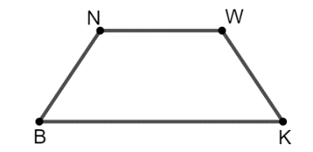
- Isosceles trapezoid $NWKB$ where $NB=3x-1$, $BK=5x+1$, and $WK=x+5$ is shown. What is an equation that can be used to find the value of $x$?

$$x+5=3x-1$$

